LAB RECORD: FTP LOGIN TESTING USING THC HYDRA
Aim
To study the output of THC Hydra during an authorized FTP login-testing exercise and identify how connection errors affect the test. Perform this exercise only on a system you own or have explicit permission to assess.

Procedure
- Set up an isolated lab FTP server or use an explicitly authorized test host, and confirm that the service is reachable before testing.
- Prepare the lab's approved test username and password lists. Use only accounts and credentials created for this exercise.
- Run the planned Hydra FTP test from the lab terminal, following the instructor's or lab environment's approved command and scope.
- Observe the terminal output, including the number of attempts, any connection errors, and whether a valid password is reported.
- Record the result and stop the test if repeated connection errors occur. Check FTP service availability, network reachability, and server-side logs before any further authorized testing.

Observation / Result
In the supplied screenshot, Hydra reports attempts against FTP at 192.168.1.101, then displays: “all children were disabled due to too many connection errors.” The summary reports 0 valid passwords found. Therefore, the screenshot does not demonstrate a successful login or confirm that the tested credentials are valid; the run was interrupted by connection errors.

Screenshot
Original terminal output supplied for this lab record:
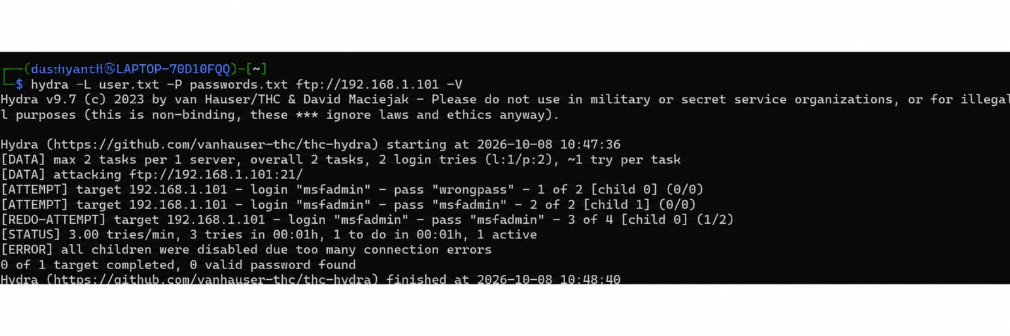

Conclusion
The test ended because of repeated connection errors, and no valid password was found. Verify service connectivity and review server logs in the authorized lab environment before drawing conclusions about the credentials.

